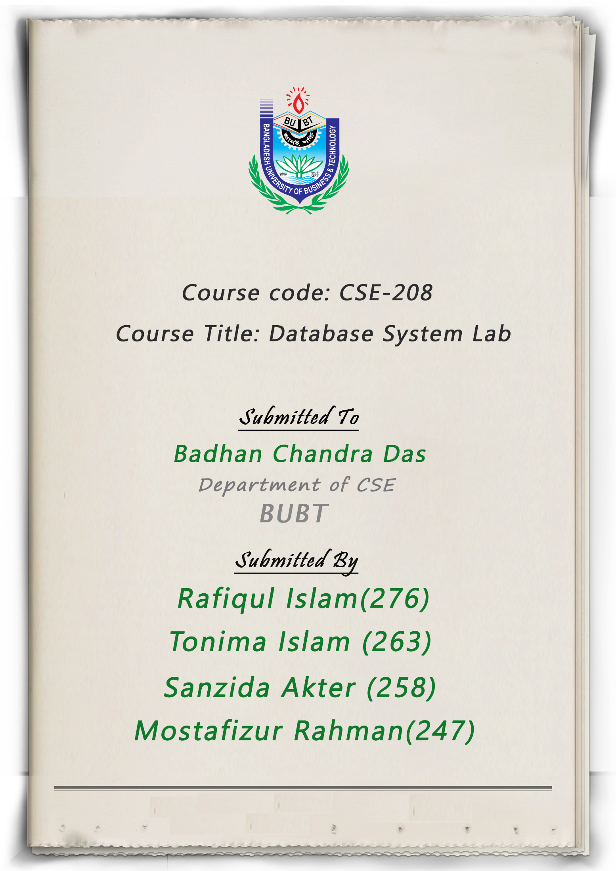

Title of the Project:

Customs Supervision System

Introduction:

Customs regulates the flow of goods into and out of a country. Most importantly,   
the customs deals with the collection of duties levied on imported goods.   
Due to the huge increase in population at present, it is hard to manage customs   
manually. Through Database management System we will create a system called   
Customs Supervision System that can reduce work pressure and fulfil all the   
needs of customs management. Customs Supervision allows you to standardize   
and automate import and export procedures with customs authorities. Our goal is   
to ensure a smooth import and export system. We want to accelerate the flow of   
work and keep pace with the changing world to make a modern world.

Aim of the project:

* Modernizing customs operations and helping to improve revenue   
  collection.
* Improving security by streamlining procedures of cargo control, transit of   
  goods and clearance of goods.
* We can view databases from across the world.
* We can easily find how many countries imported and exported in a year
* Can easily find out what products are in the warehouse.
* Changing the pattern of conventional problematic consumer demand.
* Changing the conventional problematic terms of trade.
* Changes in the pattern of conventional problematic production.
* Promoting sustainable development by cutting down on the use of paper, through the use of electronic transactions and documents
* Facilitating trade efficiency and competitiveness by substantially reducing   
  transaction time and costs.
* Helping fight corruption by enhancing the transparency of transactions.

Background:

Problem Define:

* Production section of the maximum company is doing the work manually.
* All the works are carried out in pen and paper.
* Sometimes administrator can not get proper information about the product.
* Buyers can not place the order easily.
* This system is not eﬃcient and takes long time.

Features :

* Login System
* Manage all Information efficiently.
* Record Employee and Customer Billing details.
* Add, Update & Delete all information easily.
* Advanced Search features.
* Manage Security

Entities:

The main entities of Custos Supervision System are:

Importer(Importer ID, Company Name, Trade License, Phone Number, email, password)

Admin(Name, Email, Phone, Password)

Exporter(Exporter ID, Company Name, Trade License, Phone Number, email, password)

Imported Product(Importer ID, Product ID, Product Type, Import Country)

Exported Product(Exporter ID, Product ID, Product Type, Export Country)

Exported Country(Country, Product Type)

Imported Country(Country, Product Type)

Im_Customs Clearance(Name of Vessel, Date of Arrival, Importer ID, Trade License, Product Type, Product ID, importer Country, Total tax Amount )

Ex_Customs Clearance(Name of Vessel, Date of Exported, Exporter ID, Trade License, Product Type, Product ID, Exporter Country, Total tax Amount )

Warehousing fee(Product Type, percentage)

Product in Warehouse(Product Type, Product Weight, Owner ID)

[Apply_for_clearence](http://localhost/phpmyadmin/index.php?route=/sql&server=1&db=import_export&table=apply_for_clearence&pos=0)(name_of_vessel, date, user_id, trade_license, product_type, i_e_product_id, product_weight, i_e_country, total_tax_amount)

ER Diagram:

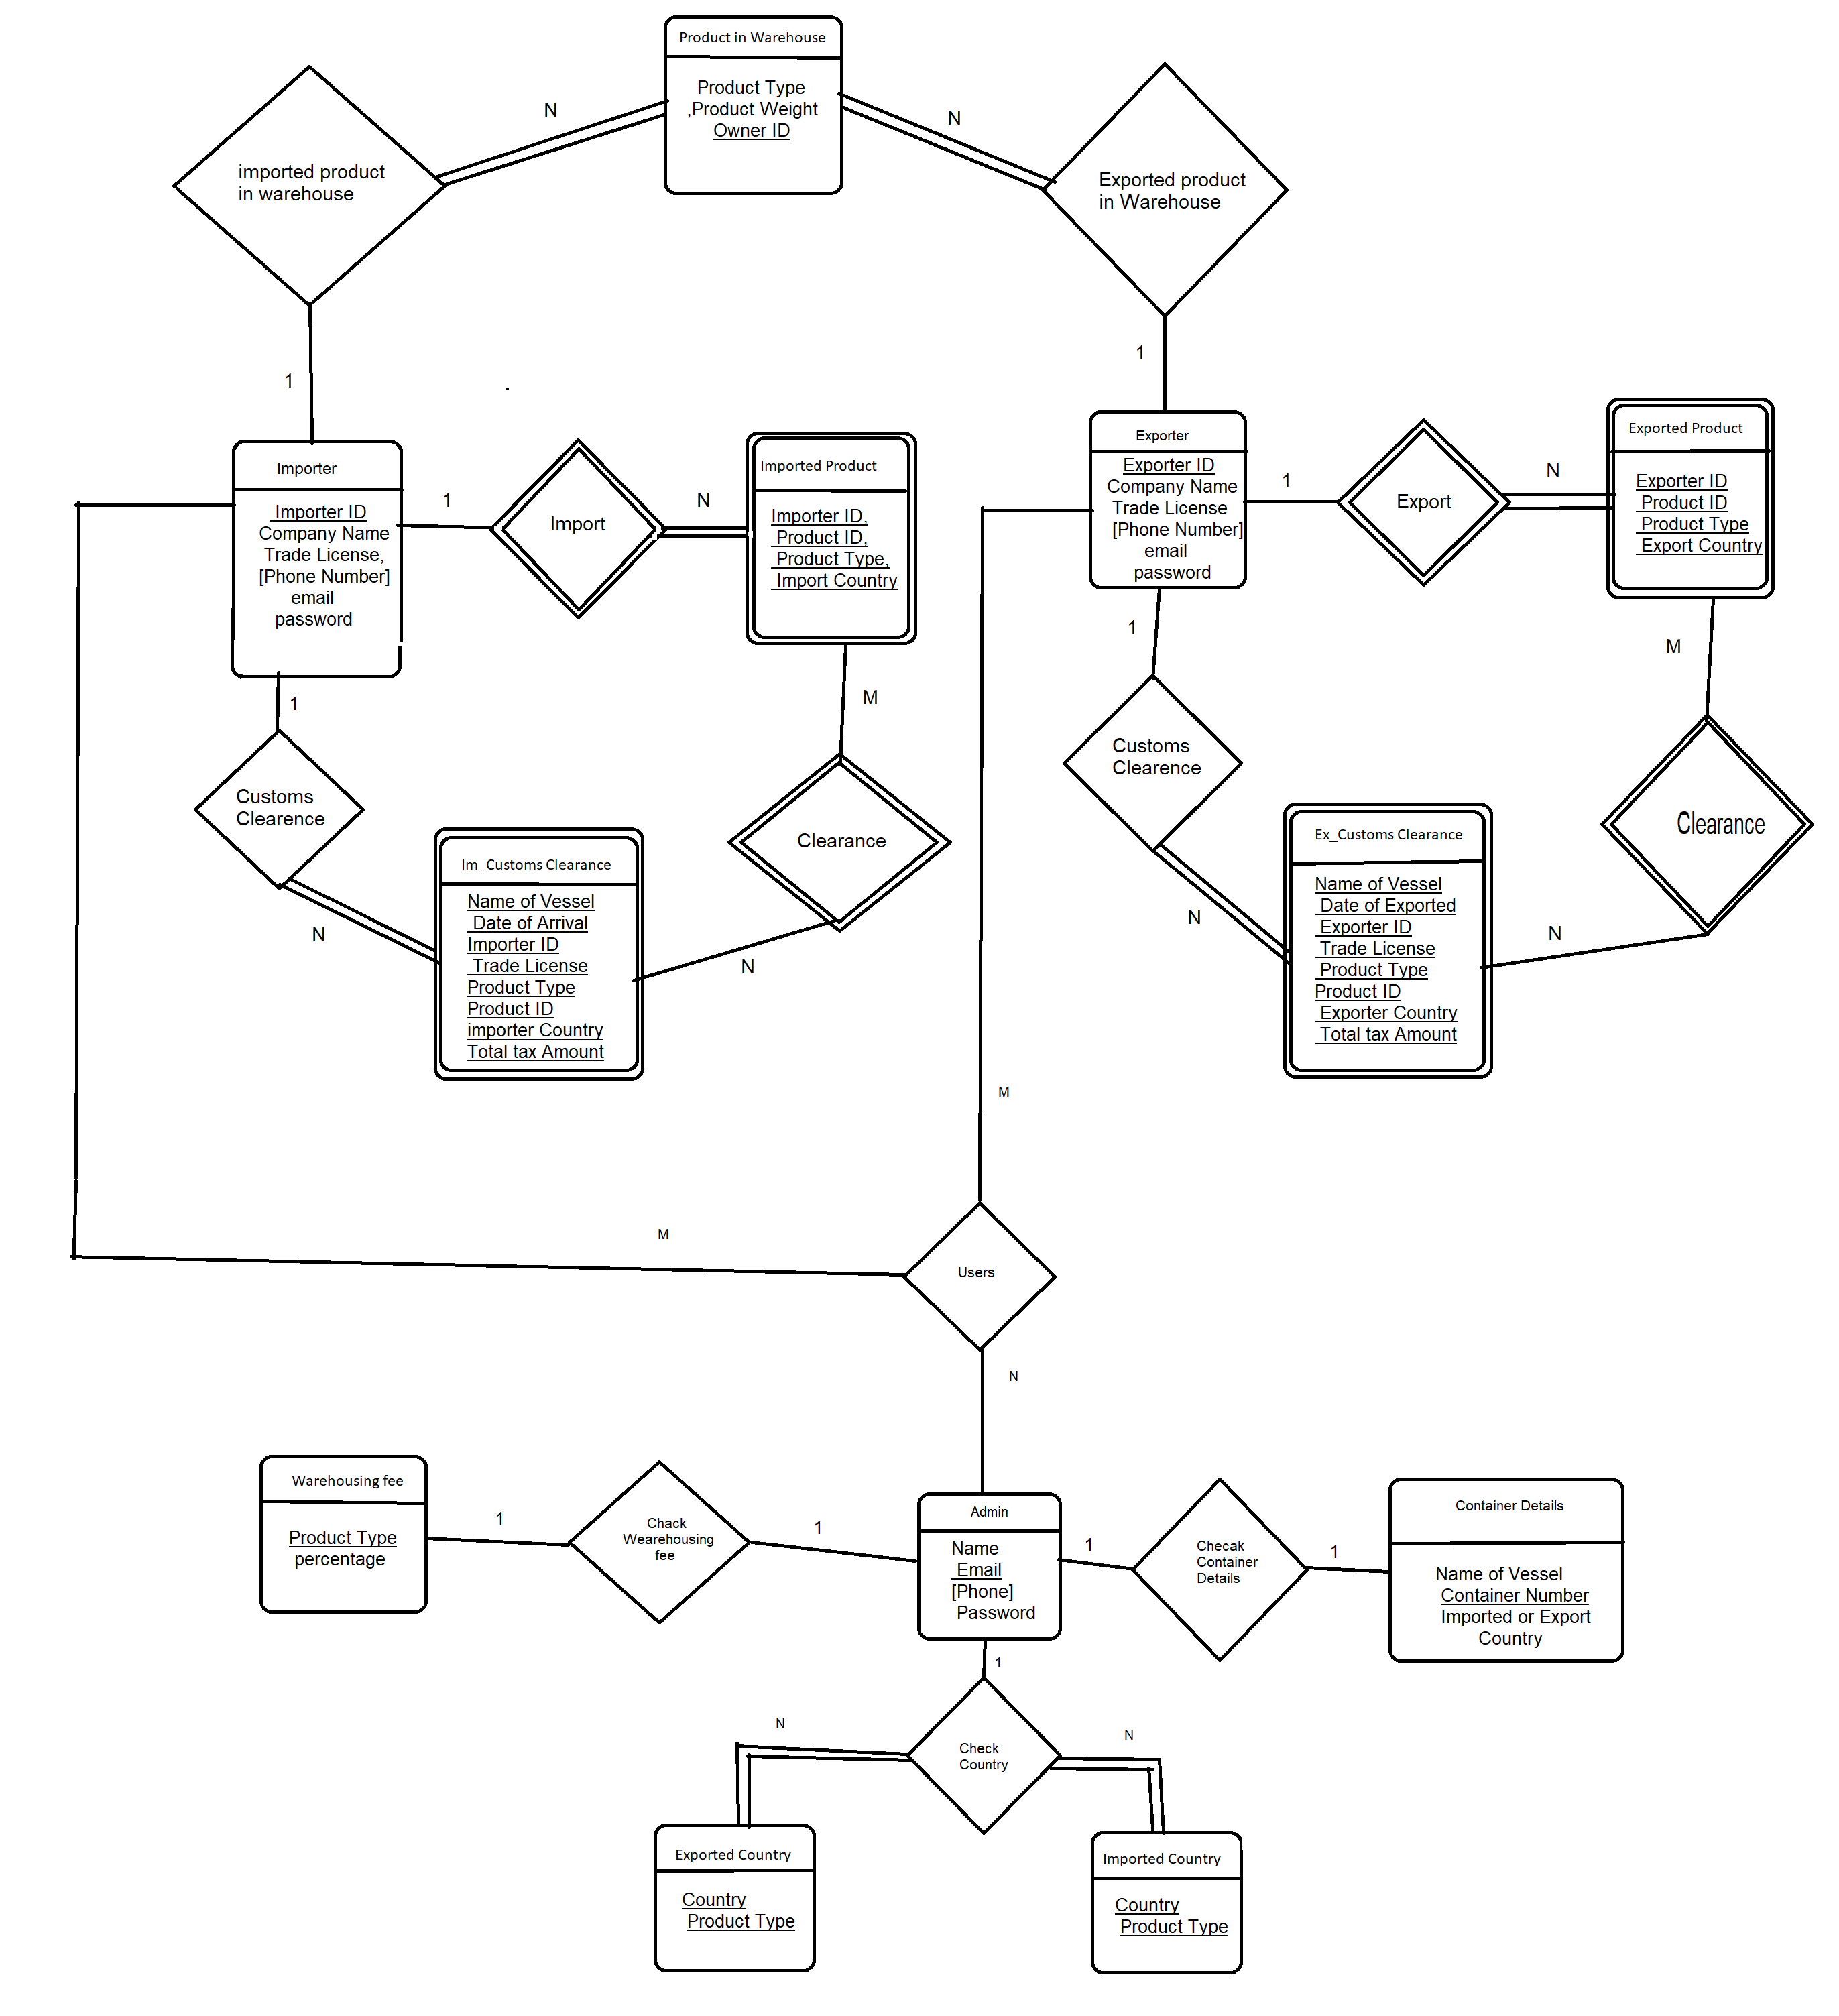

Main Features:

Admin:

* Insert [Importer, Exporter]
* Delete [Importer, Exporter]
* Check Warehousing Fee
* Approve Clearance
* Add Warehouse Product
* Delete Exported Product
* Check imported & exported Country’s

Importer:

* See All Imported Product
* Product in Warehouse
* Apply for Customs Clearance
* Warehouse Fee
* Total Paid Tax
* All Clemence
* My Account

Exporter:

* See All Exported Product
* Product in Warehouse
* Apply for Export
* Warehouse Fee
* Total Paid Tax
* All Approval
* My Account

Experiment Results:

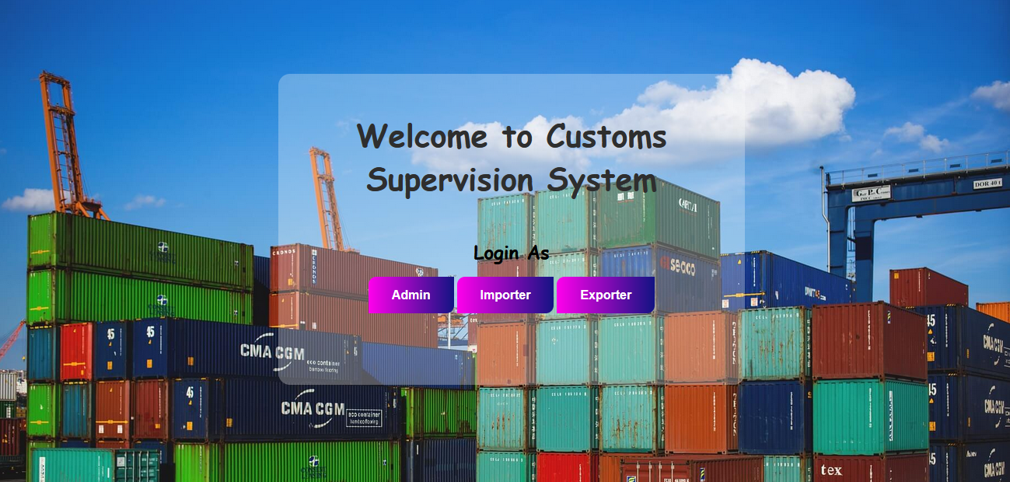

**Admin Panel**

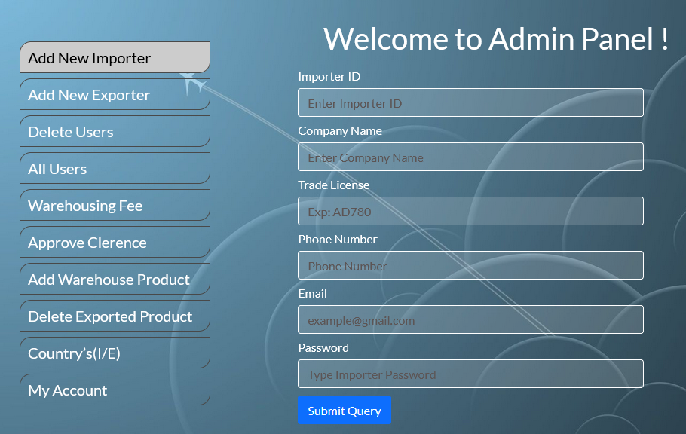

**Query For Add New Importer:**

INSERT INTO `importer`(`importer_id`, `company_name`, `trade_license`, `phone`, `email`, `password`) VALUES(?, ?, ?, ?, ?, ?);

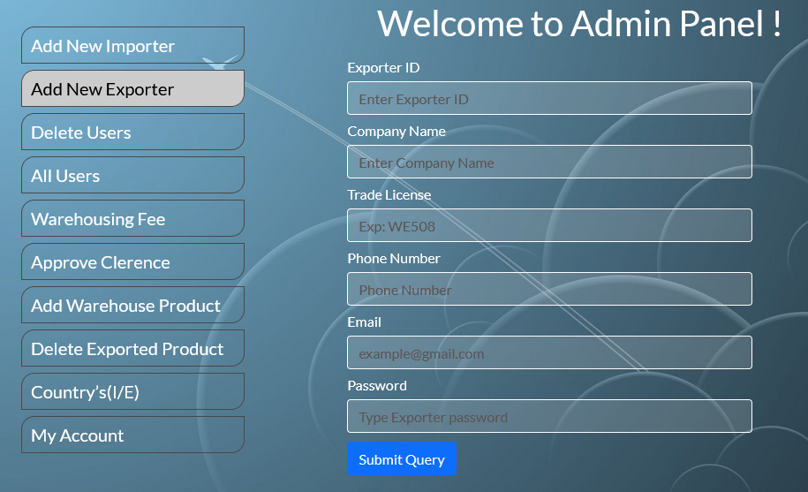

**Query for Add New Exporter:**

INSERT INTO `exporter`(`exporter_id`, `company_name`, `trade_license`, `phone`, `email`, `password`) VALUES(?, ?, ?, ?, ?, ?);

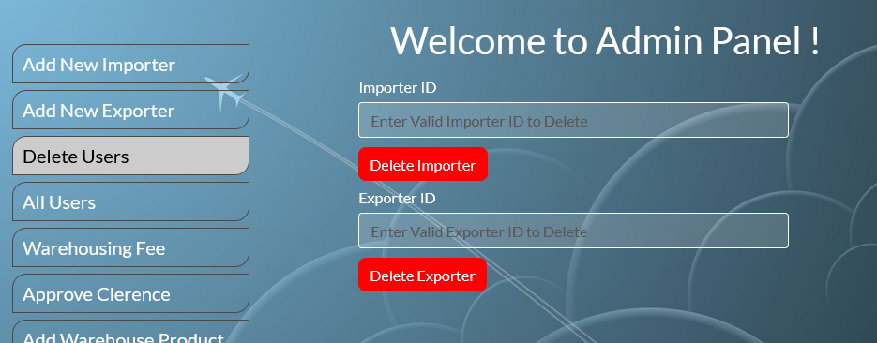

**Query for Delete Users:**

For Delete Importer:

DELETE FROM importer WHERE importer_id = '$delete_importer’;

For Delete Exporter:

DELETE FROM exporter WHERE exporter_id = '$delete_exporter’;

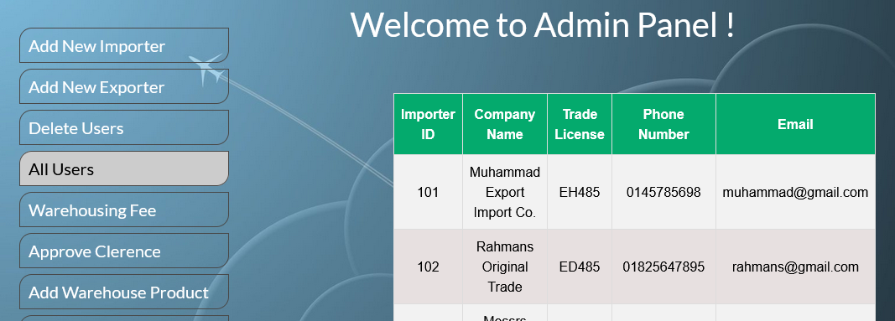

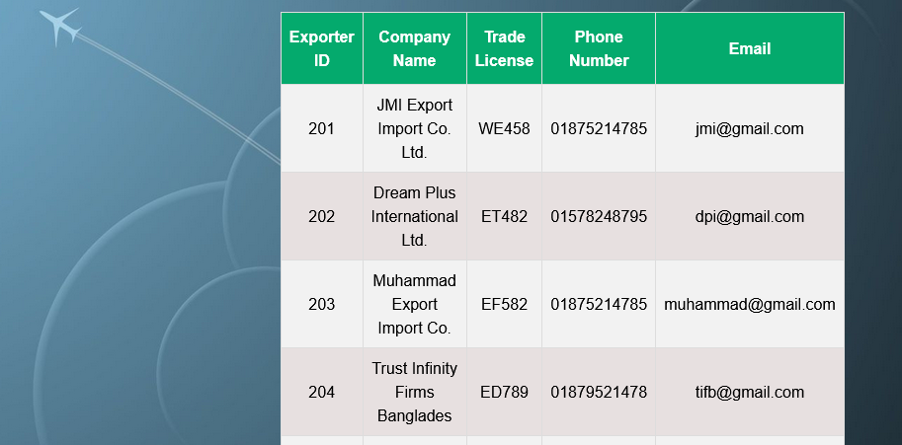

**Query for All Users:**

For Importer:

SELECT * FROM importer ORDER BY importer_id ASC;

For Exporter:

SELECT * FROM exporter ORDER BY exporter_id ASC;

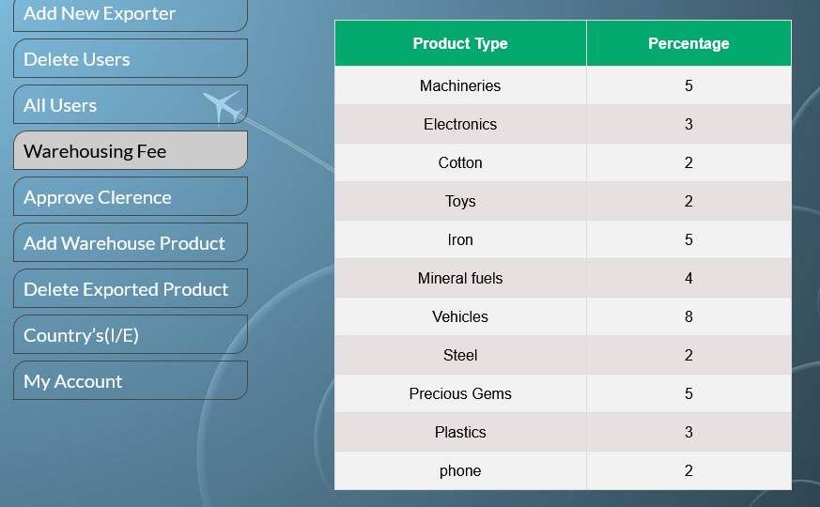

**Query for Warehousing Fee:**

SELECT * FROM warehouse_fee;

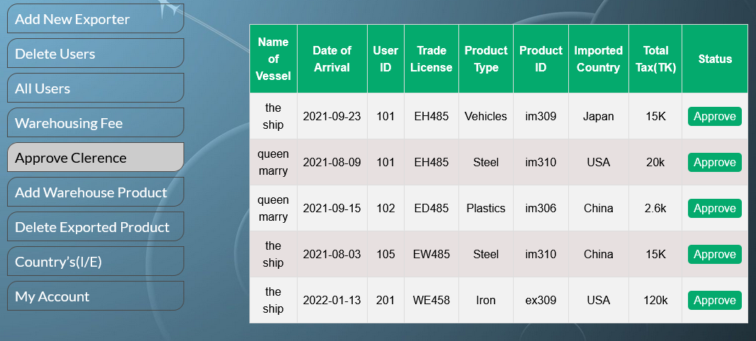

**Query for Approve Clearance:**

SELECT * FROM apply_for_clearence ORDER BY user_id ASC;

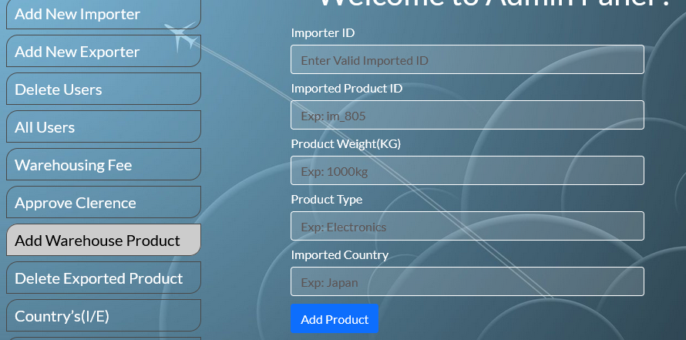

**Query for Add Warehouse Product:**

INSERT INTO `im_warehouse`(`importer_id`, `im_product_id`, `product_weight`, `product_type`, `country`) values(?, ?, ?, ?, ?);

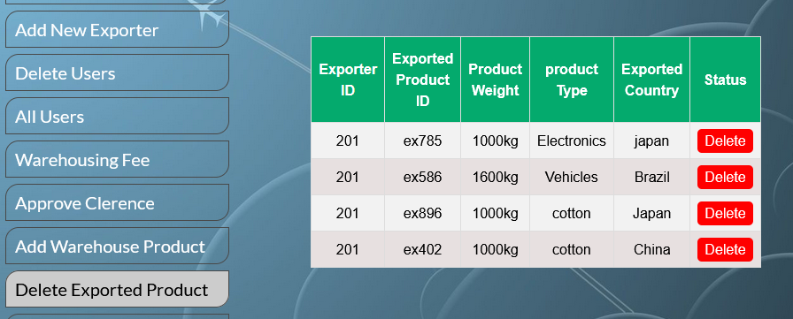

**Query for Delete Exported Product**:

DELETE FROM `ex_warehouse` WHERE exporter_id = '$delete_id';

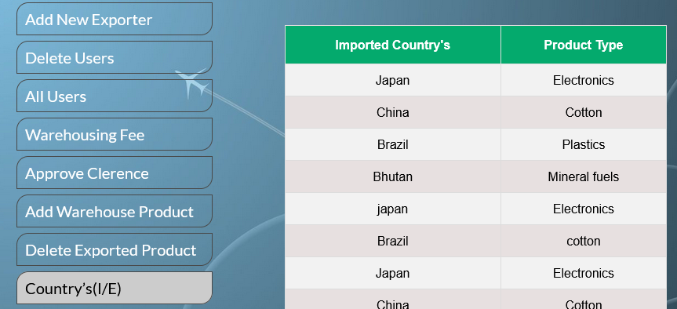

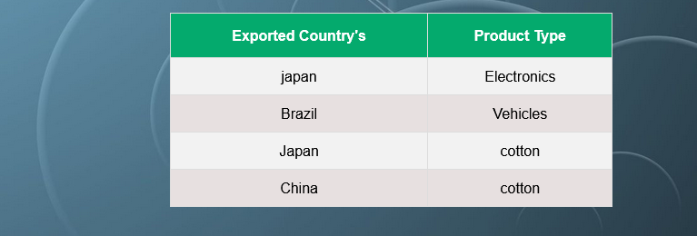

**Query for Country’s(I/E):**

For Imported Country’s:

SELECT * FROM imported_country;

For Exported Country’s:

SELECT * FROM exported_country ;

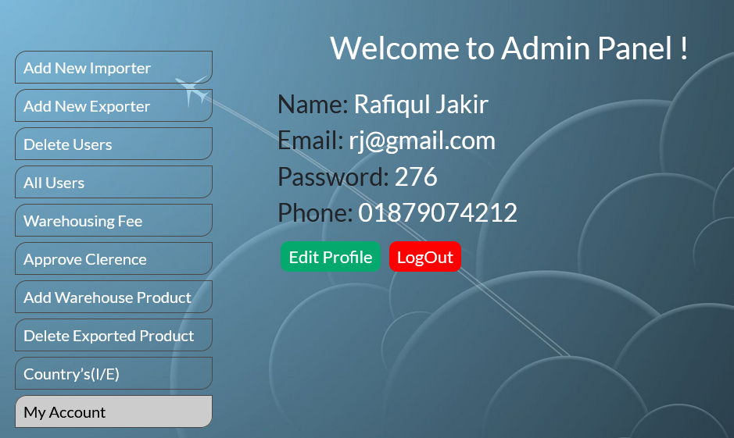

**Query for My Account:**

SELECT * FROM `admin` WHERE email = '$admin_email’;

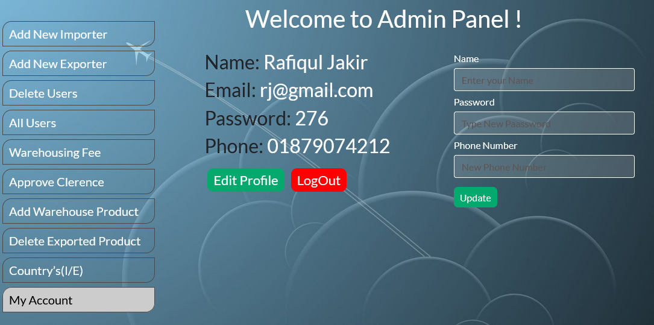

**Query for Update Profile:**

UPDATE admin SET name='$update_name' ,password='$update_password’,

phone='$update_phone' WHERE email = '$admin_email';

**User Panel (Importer)**

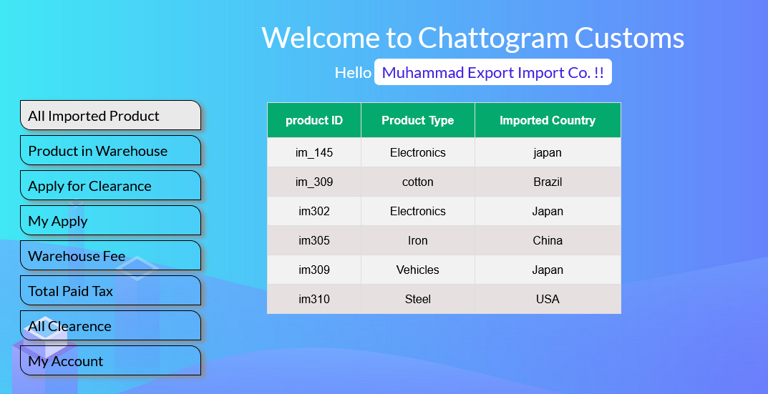

**Query for All Imported Product:**

SELECT * FROM `imported_product` WHERE importer_id IN(SELECT   
importer_id FROM importer WHERE email = '$ importer_email);

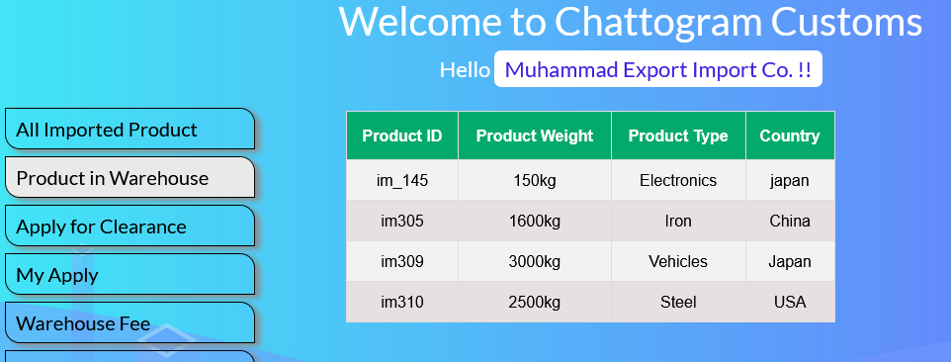

**Query for Product in Warehouse:**

SELECT im_product_id,product_weight,product_type,country FROM   
im_warehouse WHERE importer_id IN(SELECT importer_id FROM   
importer WHERE email = '$ importer_email)’;

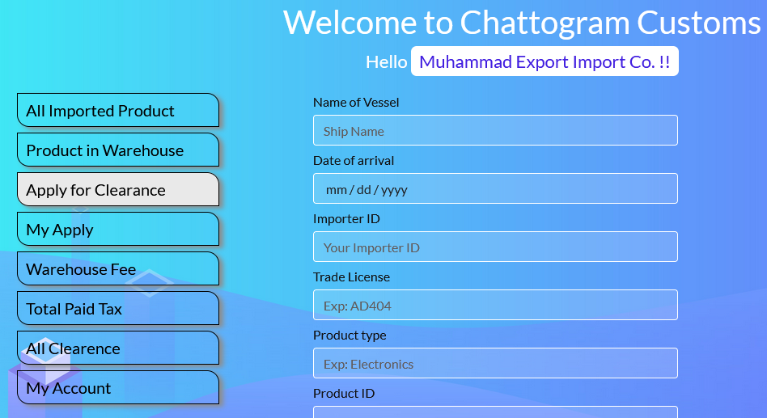

**Query for Apply for Clearance:**

INSERT INTO `apply_for_clearence`(`name_of_vessel`, `date`,   
`user_id`, `trade_license`, `product_type`, `i_e_product_id`, `product_weight`, `product_weight`, `i_e_country`, `total_tax_amount`)   
values(?, ?, ?,?, ?, ?, ?,?,?)

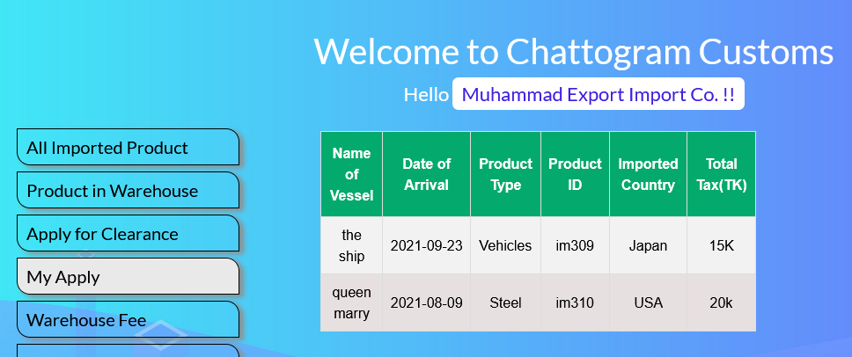

**Query for My Apply:**

SELECT * FROM `apply_for_clearence` WHERE user_id IN(SELECT   
importer_id FROM `importer` WHERE email = '$ importer_email);

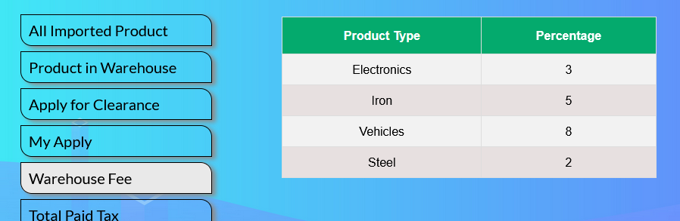

**Query for Warehousing Fee:**

SELECT * FROM `warehouse_fee` WHERE product_type IN(SELECT product_type FROM `im_warehouse` WHERE importer_id IN(SELECT importer_id FROM `importer` WHERE email = '$importer_email'))

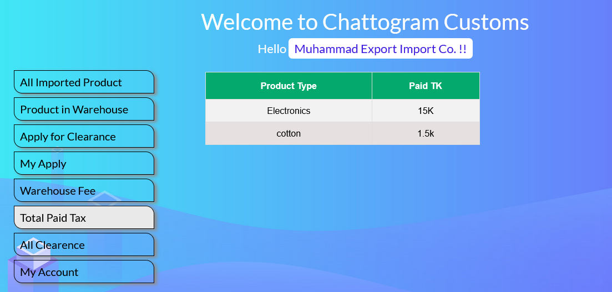

**Query for Tatal paid Tax:**

SELECT product_type,total_tax_amount FROM   
`im_customs_clearance` WHERE importer_id IN(SELECT importer_id FROM `importer` WHERE email ='$importer_email')

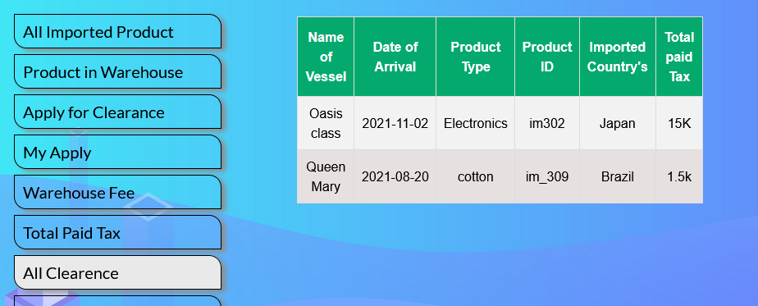

**Query for All Clearance:**

SELECT name_of_vessel,date_of_arrival, product_type,   
im_product_id, importer_country,total_tax_amount FROM   
im_customs_clearance WHERE importer_id IN(SELECT importer_id FROM importer WHERE email = '$importer_email')

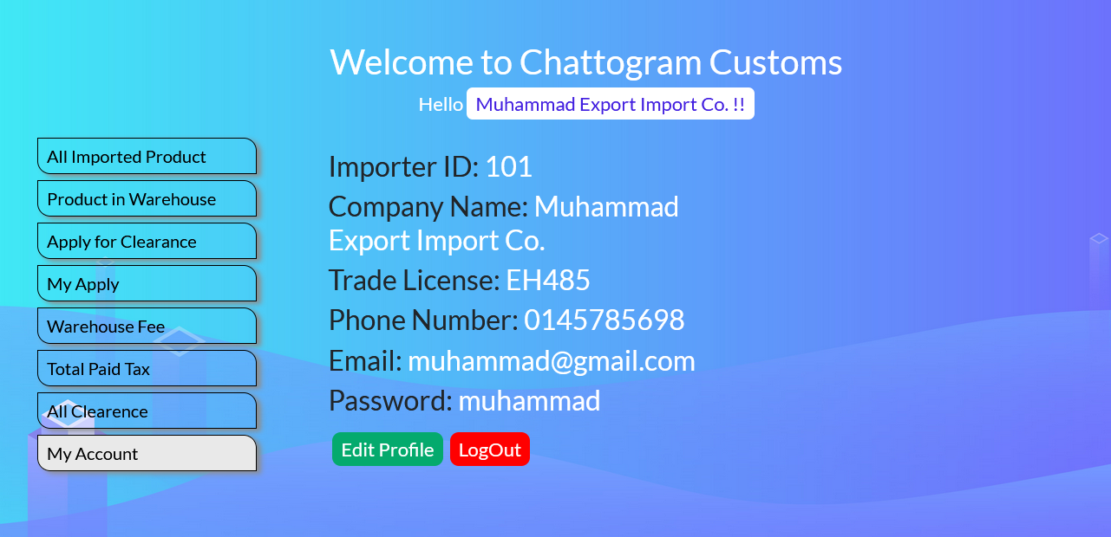

**Query for My Account:**

SELECT * FROM importer WHERE email='$importer_email';

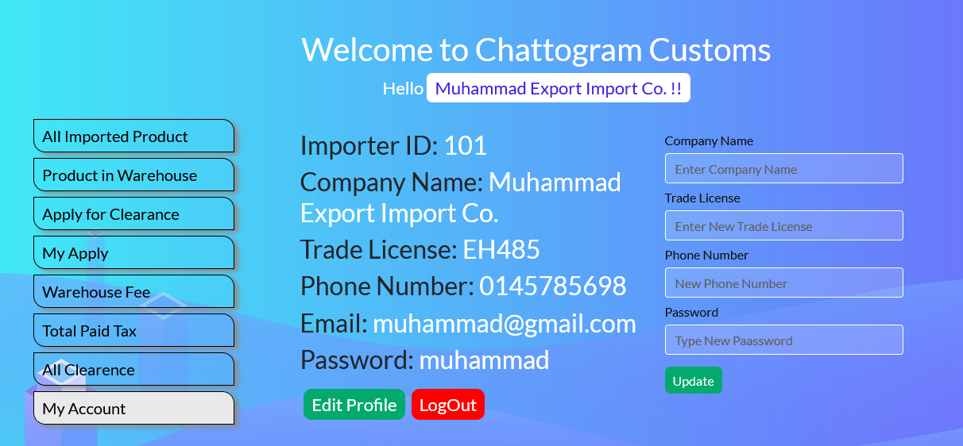

**Query for Update Profile:**

UPDATE `importer` SET `company_name`='$company_name', `trade_license`='$trade_license', `phone`='$update_phone', `password`='$update_password' WHERE email = '$importer_email'

**User Panel(Exporter)**

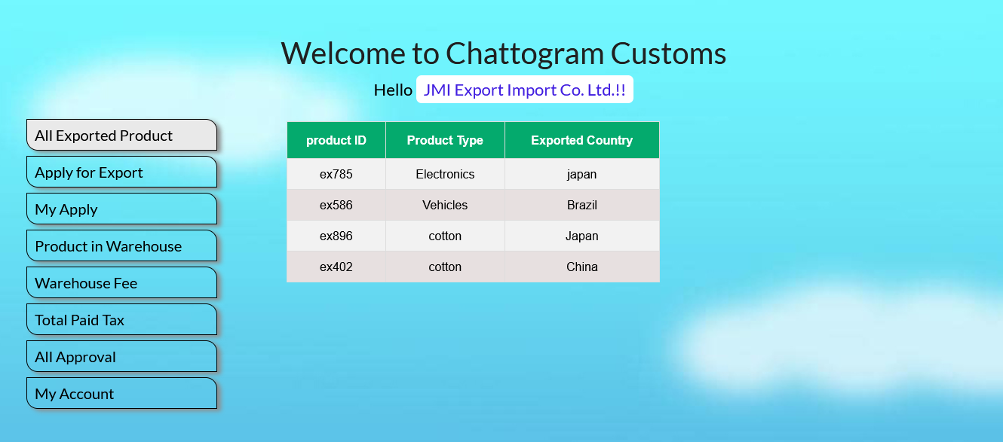

**Query for All Exported product:**

SELECT * FROM `exported_product` WHERE exporter_id IN(SELECT   
exporter_id FROM exporter WHERE email = '$exporter_email');

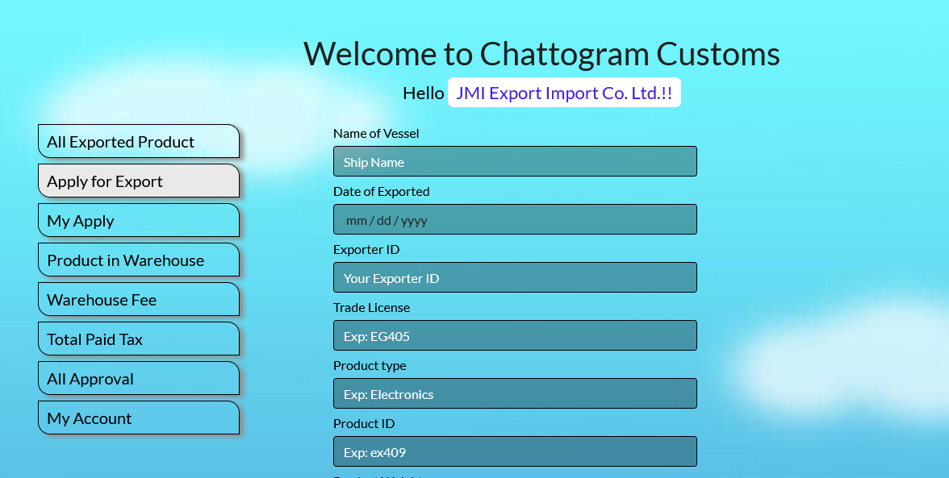

**Query for Apply for Export:**

INSERT INTO `apply_for_clearence`(`name_of_vessel`, `date`,   
`user_id`, `trade_license`, `product_type`,   
`i_e_product_id`,`product_weight`, `i_e_country`, `total_tax_amount`)   
values(?, ?, ?,?, ?, ?, ?,?,?);

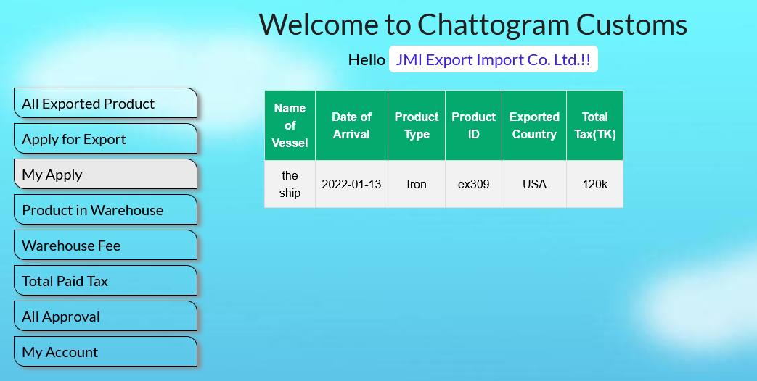

**Query for My Apply:**

SELECT * FROM `apply_for_clearence` WHERE user_id IN(SELECT

exporter_id FROM `exporter` WHERE email = '$exporter_email')

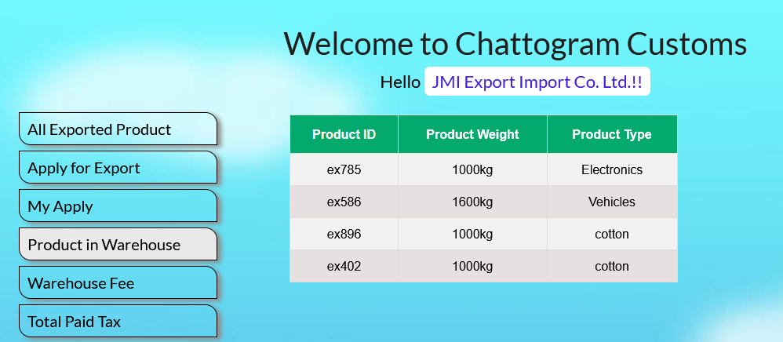

**Query for Product in Warehouse:**

SELECT ex_product_id,product_weight,product_type FROM   
ex_warehouse WHERE exporter_id IN(SELECT exporter_id FROM exporter   
WHERE email = '$exporter_email')

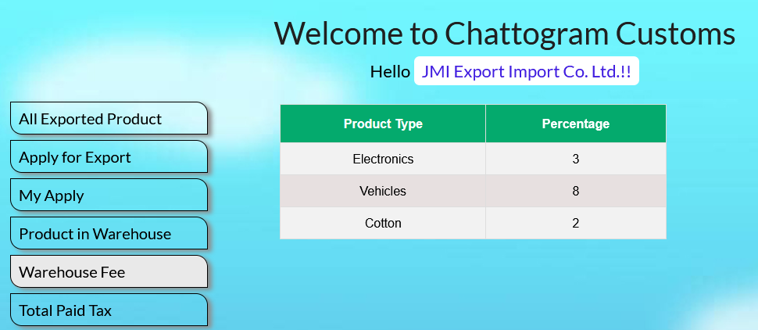

**Query for Warehouse Fee:**

SELECT * FROM `warehouse_fee` WHERE product_type IN(SELECT   
product_type FROM `ex_warehouse` WHERE exporter_id IN(SELECT   
exporter_id FROM `exporter` WHERE email = '$exporter_email'));

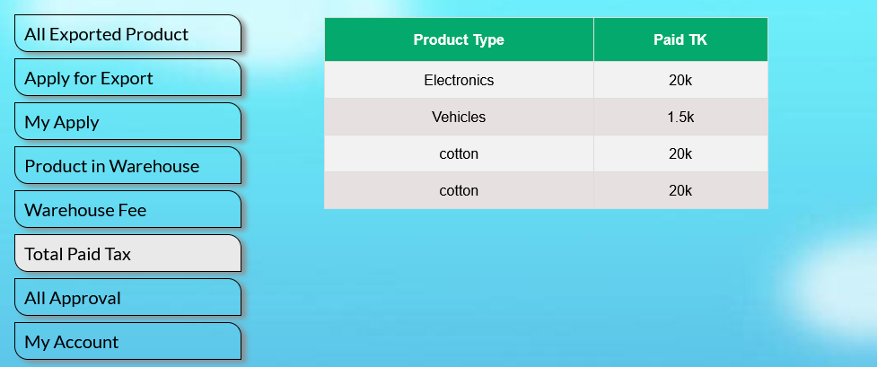

**Query for Total paid Tax:**

SELECT product_type,total_tax_amount FROM `ex_customs` WHERE   
exporter_id IN(SELECT exporter_id FROM `exporter` WHERE email   
='$exporter_email');

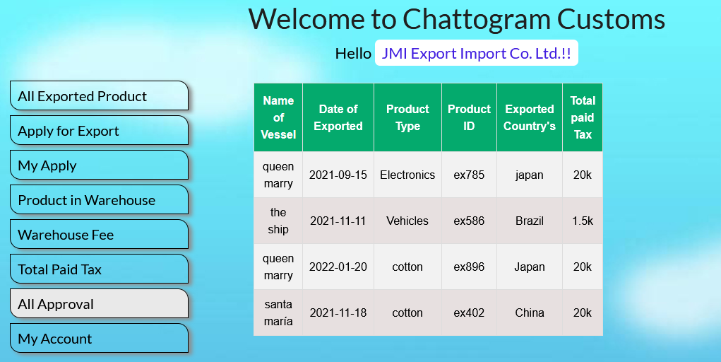

**Query for All Approval:**

SELECT name_of_vessel,date_of_exported,product_type,   
ex_product_id,exporter_country,total_tax_amount FROM ex_customs   
WHERE exporter_id IN(SELECT exporter_id FROM exporter WHERE email   
= '$exporter_email');

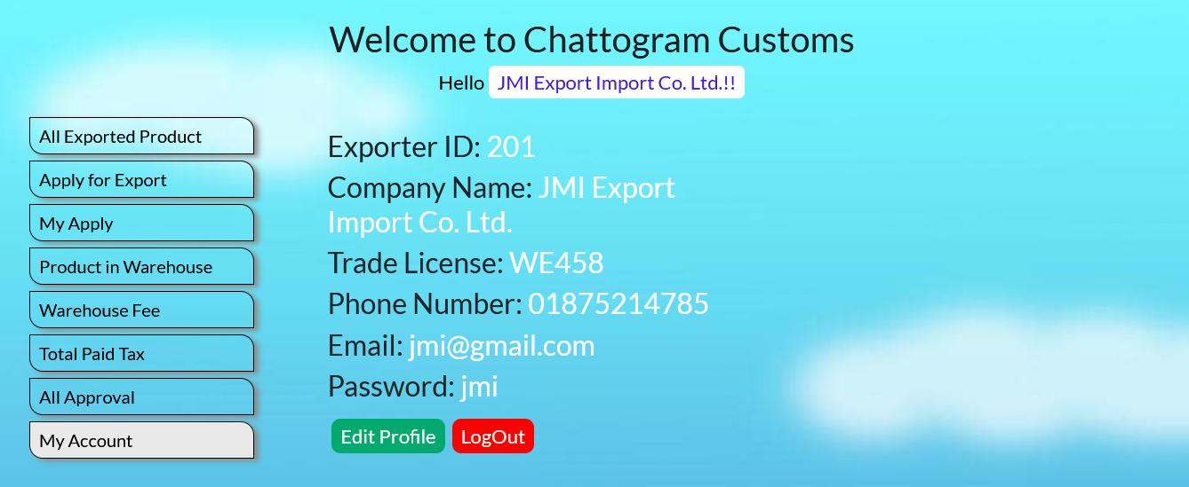

**Query for My Account:**

SELECT * FROM exporter WHERE email='$exporter_email';

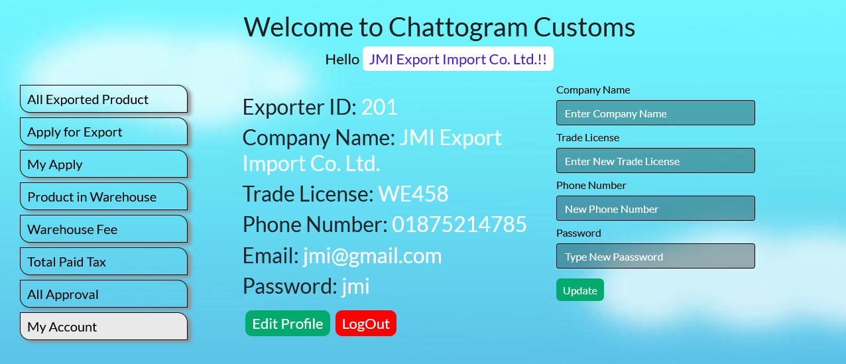

**Query for Update Profile:**

UPDATE `exporter` SET `company_name`='$company_name',   
`trade_license`='$trade_license',`phone`='$update_phone',`password`='$  
update_password' WHERE email = '$exporter_email';

**Discussion:**

We made our project with an interface using PHP. In our Customs Supervision System, there are 3 panels- Admin, Importer, Exporter.

**Admin panel**: An admin can add an importer or exporter by inserting their details.

Also, an admin can delete any importer or exporter by entering their ID. Admin can see importer and exporter information through All Users and also can see warehousing fee for every product in Warehousing Fee.

When an importer applies for their product clearance then the admin can approve that product through Approve Clearance. They add an imported or exported product to the warehouse through Add Warehouse product. After exportation of a product, they will delete that product through Delete Exporting Product. An admin can see all the countries where imports and export made so far. And last the My Account section in the admin panel, where they can see their account details and they can also update their account anytime.

**Importer panel**: An admin can see all imported products they have imported so far and product details in All Imported products. At Product in Warehouse, they can see how many of their product arrived and are stored there. They can see every product detail here. If they want to get any of their products which already arrived from another country they have to apply for clearance from Apply for clearance option. They can see how much cost for their every product for storing it in the warehouse through Warehouse Fee. They can also see how much tax is assigned for each product and the tax paid by them in Total Paid Tax. After making their clearance they can see that product and details in All Clearance. They can also see and update their profile in My Account like admin.

**Exporter panel**: The exporter panel is a kind of similar to the importer panel. They can see all of their exported product through All Exported Product. They can apply for their product exportation and also can see their application like importer panel. They will see how many of their product are stored and their details at Product in Warehouse. They will see how much costing their every product through Warehouse Fee. And also they can see how much tax is assigned for each product in Total Paid Tax. An exporter can see how of their product approved by admin so far in All Approval. Lastly, there will be an option for My Account here they can see their profile and update it like admin and importer.

Conclusion:

In the present situation where the population is growing fast, it has become very difficult to maintain our old systems. Due to which many of our needs are not being met and we are losing many opportunities.   
The world is moving very fast with technology. If we do not pace with it, we will fall behind. This is a small effort from us to take part to keep pace with the advancing world of technology. Our project will make the import and export process easier. The quality and quantity of industrial production will increase. New chances will increase for the young generation through our project. With all these factors in mind, we have taken the initiative to implement this project to save our generation from mentioned difficulties.